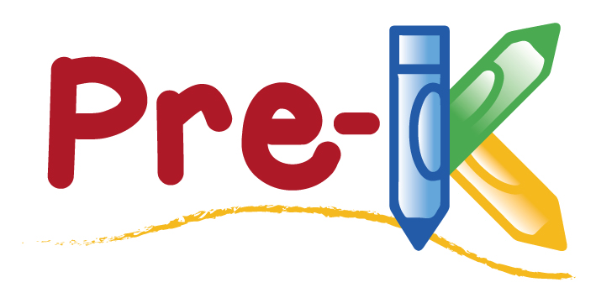

2019-2020 School Year Supply List

- 2 -24 PACK OF CRAYOLA CRAYONS

- 1-10 COUNT PACK OF CRAYOLA WASHABLE MARKERS

- 2-LARGE ELMER’S WASHABLE SCHOOL GLUE STICK

- 1-8 COUNT CRAYOLA WASHABLE WATERCOLORS

- 1-BOX OF FACIAL TISSUE

- 2- Beginners Pencils

- CHANGE OF SEASONAL CLOTHING (PLEASE INCLUDE UNDERWEAR, SOCKS, AND SHOES IF POSSIBLE)

BOYS: PRESS AND CLOSE SANDWICH
BAGS / BABY WIPES

GIRLS: PRESS AND CLOSE GALLON SIZE
BAGS / DISENFECTING WIPES

